Table of Contents
1. Introduction 2
2. The Real-World Problem & Objectives 3
Project Objective 3
3. Modular Architecture & Design Decisions 3
Technical Benefits of File Separation 4
4. Technical Implementation & Assignment Task Mapping 4
5. Digital Public Goods (DPG) Alignment 11
Privacy-Respecting & Data Minimisation 11
6. Program Execution & Sample Output Screenshots 12
7. Conclusion 14

Introduction
In modern healthcare administration, efficient patient data management is vital for delivering timely, high-quality medical services. However, many small community clinics, primary health centers, and rural health posts continue to rely on manual, paper-based logbooks and physical files to record patient interactions. While paper registers are traditional, they suffer from inherent drawbacks: physical degradation over time, susceptibility to loss or damage, slow search and retrieval times, and severe privacy risks when patient files are left physically exposed.

To solve these real-world healthcare challenges, this project introduces the Patient Record System, a lightweight, offline-first digital software developed in Python using Object-Oriented Programming (OOP) principles. Developed in strict alignment with Digital Public Goods (DPG) standards, this application requires no internet connectivity, paid licenses, or high-end infrastructure, providing an open-source, accessible, and privacy-respecting solution tailored for resource-constrained medical environments.

The Real-World Problem & Objectives
Paper-based record management introduces several critical operational bottlenecks in clinical settings:
Time-Consuming Search: Locating a specific patient's past file among dozens of thick physical registers is slow and inefficient.
Risk of Loss and Damage: Paper records are vulnerable to physical deterioration, loss, misplaced pages, or environmental damage.
Difficult Visit Tracking: Tracking recurring follow-up visits, admission statuses, or discharge histories across separate paper logs is cumbersome and prone to human error.

Project Objective:
The objective of this project is to implement a robust, clean, and user-friendly command-line application that automates patient registration, department assignment, visit tracking, and patient discharge workflows. By prioritizing data minimization and privacy-preserving design, the system ensures that patient information is handled securely and efficiently.

Modular Architecture & Design Decisions
A core architectural decision in this project is separating every class into its own dedicated Python file (Modular Structure):
department.py: Contains the Department class, its associated ward attributes, and the tuple of available hospital departments.
patient.py: Contains the Patient class, patient attributes, visit logging logic, and data validation helper functions.
patient_record_system.py: Contains the main application execution loop, menu interface, data structure management, and demo seeding functions.

Technical Benefits of File Separation:
Maintainability & Cleanliness: Isolating classes into separate files prevents code clutter. If a bug occurs or a class feature needs updating, changes are made directly in that specific file without risking accidental side effects in other parts of the program.

Scalability: The modular design simplifies future expansions. If additional domain classes are required later (e.g., Doctor, Prescription, or Billing), they can be added as standalone modules without altering or breaking existing core logic.

Reusability: Each class file operates as an independent module. For instance, department.py or patient.py can be imported directly into other medical software projects without modification.

Technical Implementation & Assignment Task Mapping
Task 1
Department Class: Represents a hospital ward/department where care is provided. Attributes include name and ward.

Patient Class: Represents an individual patient record. Attributes include auto-generated ID (patient_id, e.g., PT-001), name, age, district, condition, visits, status (ADMITTED / DISCHARGED), and a reference to a Department object.

Object Interaction: A Patient object encapsulates a Department object (self.department = department). When Patient.display_info() is called, it internally invokes self.department.display_info(), demonstrating direct interaction between separate objects.

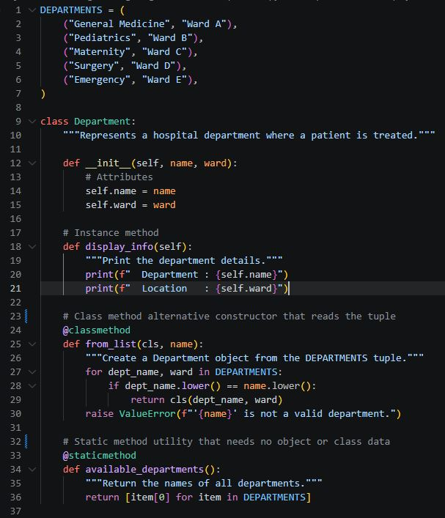
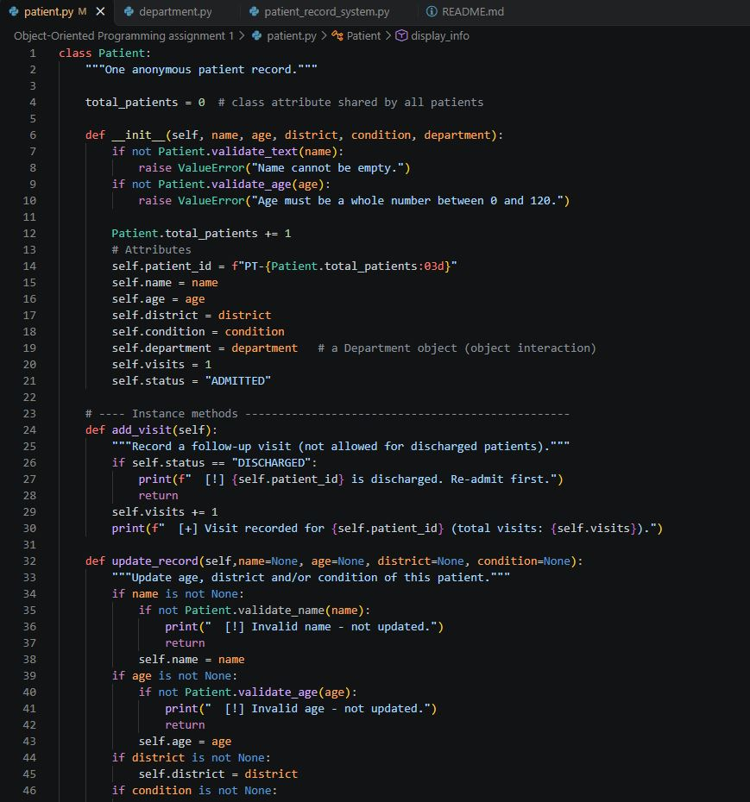
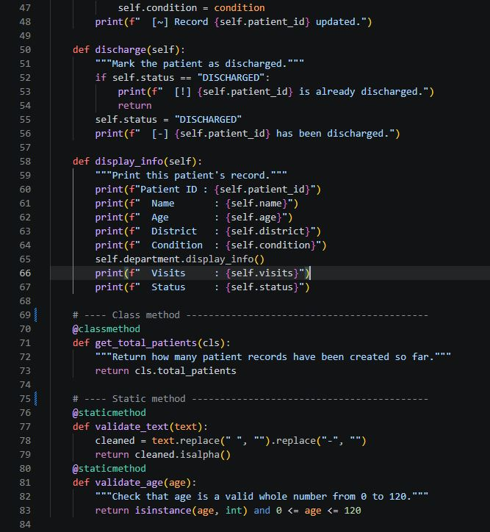
Task 2: Data Structures & Management Functions
Dictionary Data Structure: The program uses a Python dictionary (records = {}) initialized in main() to store patient records. The unique patient ID serves as the dictionary key ({patient_id: Patient}), enabling fast $O(1)$ record lookups.
Management Functions: add_patient() adds a new record to the dictionary, while display_patients() iterates through dictionary values to present all stored records in a formatted layout.
Bonus Mark Requirement (Tuples): The constant DEPARTMENTS in department.py utilizes nested tuples ((dept_name, ward), ...) to maintain an immutable list of supported hospital departments and locations.

Task 3: Methods & DPG Standards Implementation
Instance Methods:
add_visit(): Records follow-up visits (automatically blocked if the patient is already discharged).
update_record(): Modifies patient details such as condition or district.
discharge(): Updates patient status to DISCHARGED.

Class Methods (@classmethod):
Patient.get_total_patients(): Tracks the shared class-level counter total_patients across all instances.
Department.from_list(): Acts as an alternative constructor to instantiate a Department object directly from the predefined tuple list.

Static Methods (@staticmethod):
Patient.validate_text() & Patient.validate_age(): Perform input validation on names, conditions, districts, and numeric age ranges.
Department.available_departments(): Returns available department names without requiring object instantiation.

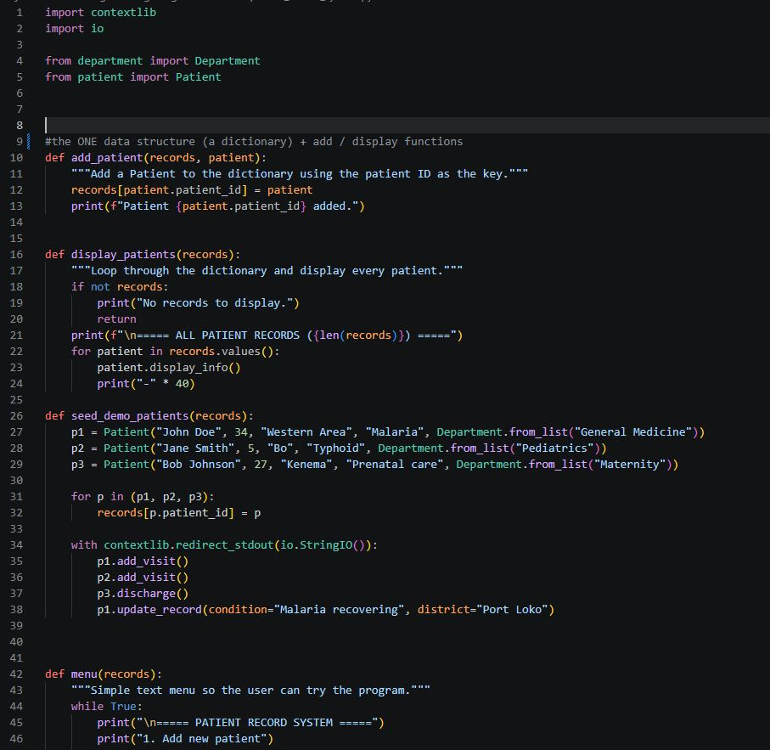

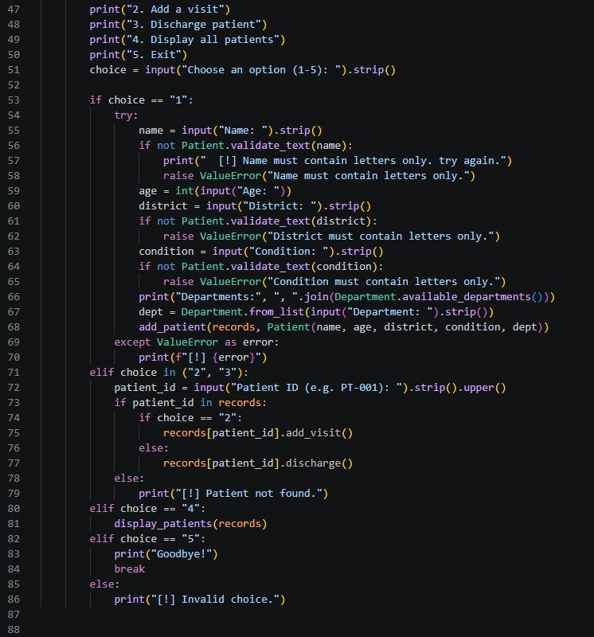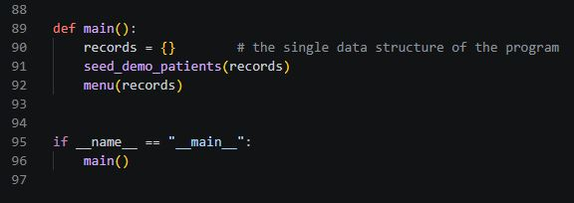

Digital Public Goods (DPG) Alignment
Open-Source: The complete source code is published in a public GitHub repository, making it freely available for anyone to audit, adapt, and improve.

Inclusive and Accessible Design: Built to run on any computer with Python 3 installed, requiring no high-end hardware, active internet connectivity, or paid software dependencies. It features a clear numbered text-based menu and plain-English output compatible with screen readers.

Privacy-Respecting & Data Minimisation:
Minimal Personal Data: Stores only non-sensitive identifiers necessary for clinic operations (name, general age, broad district, condition label, and ward). No phone numbers, street addresses, national identity numbers, or financial details are requested.

In-Memory Storage: Patient records reside strictly in temporary RAM memory during runtime and are never written to disk or transmitted over a network, preventing persistent data leaks.

Silent Startup: The program opens directly to the menu without automatically displaying patient records on screen, maintaining visual confidentiality in busy clinical environments.

Program Execution & Sample Output Screenshots

- Add New patient
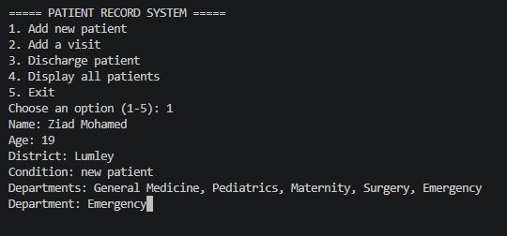

- Add a visit
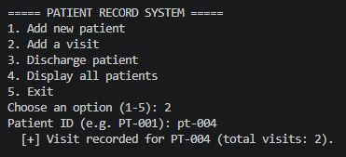

- Discharge patient
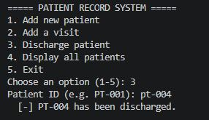
- Display All Patient
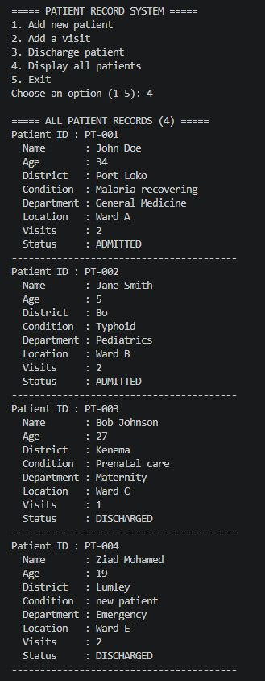

- Exit
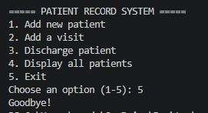

Conclusion
The Patient Record System successfully bridges the gap between traditional paper-based workflows and modern digital administration for resource-constrained healthcare environments. By implementing robust Object-Oriented Programming (OOP) principles—including strict class encapsulation, modular file separation, inter-object communication, and the strategic use of instance, class, and static methods—the application delivers a clean, scalable, and highly maintainable codebase.

Furthermore, the system’s design directly aligns with Digital Public Goods (DPG) standards by prioritizing offline accessibility, zero licensing costs, and strict data minimization. By restricting data collection to essential operational identifiers and maintaining records exclusively in memory during runtime, the application ensures high standards of patient privacy. Ultimately, this project demonstrates how lightweight, open-source software can effectively modernize clinical record management while remaining secure, ethical, and accessible to all.

